Employee Management & HR System — Product Design and Master AI Prompt
I recommend building this as a configurable, role-based HRMS and employee self-service platform with a modern web dashboard, a Go backend, SQLite database, automated approval workflows, payroll and attendance management, document expiry tracking, email notifications, and an AI help assistant.
The design should be suitable for a real organization, not just a basic employee CRUD application. Every important business rule should be configurable, every sensitive action should be auditable, and approvals should follow the organization's reporting hierarchy.
I'll structure this into three deliverables:
- Product and UI/UX design — screens, roles, workflows, and functionality.
- Technical architecture — Go, SQLite, API integrations, security, and production readiness.
- Master AI development prompt — ready to paste into an AI coding tool to build the application.
1. Product concept and visual design
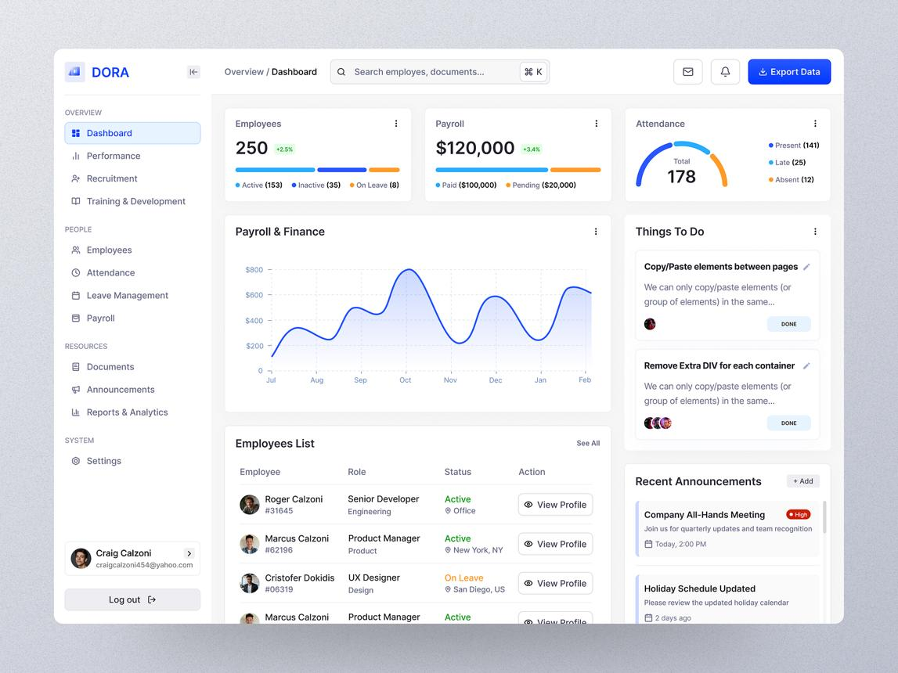
dribbble.com
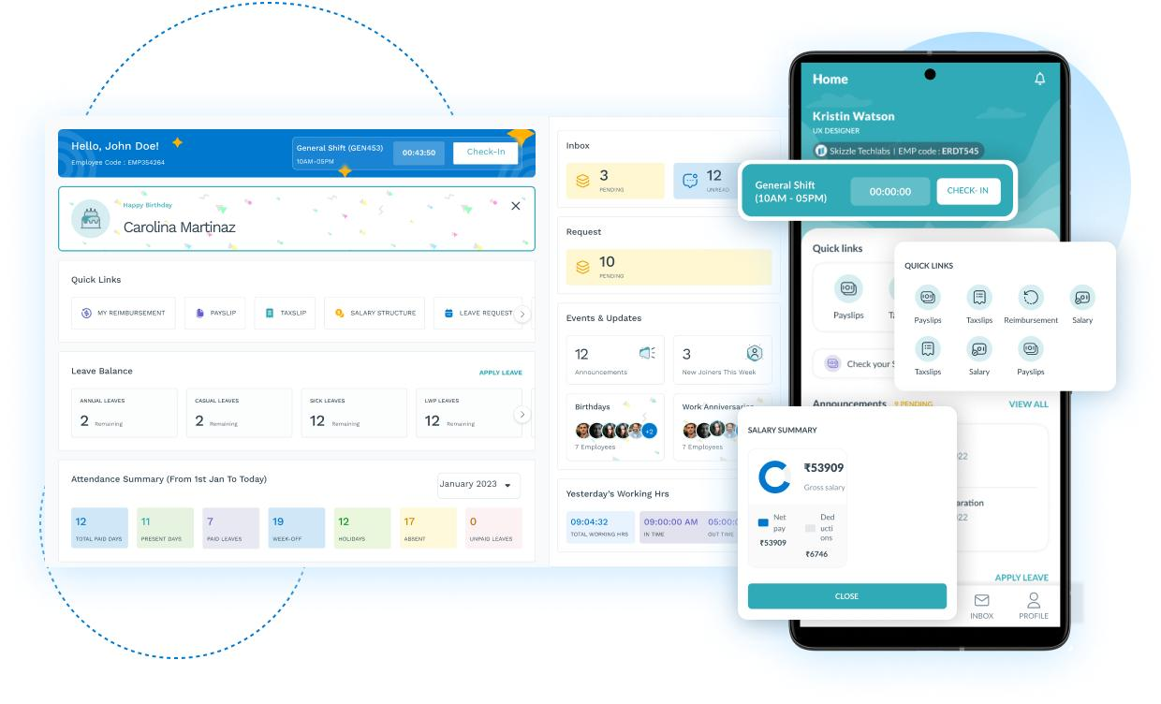
Employee self-service portal
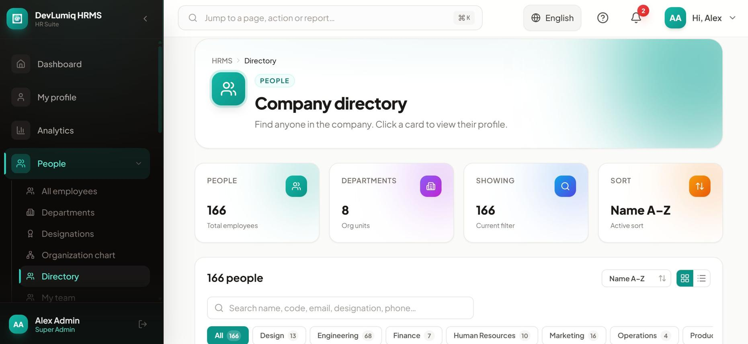
HR administration and approvals
Recommended interface
Use a clean enterprise design with a collapsible left sidebar, a top navigation bar, searchable tables, clear approval statuses, and dashboards that adapt to the user's role.
PeopleOps
Employee & Human Resources Platform
Configurable
Employees
Directory and employee lifecycle
Attendance
Check-in, shifts and timesheets
Payroll
Salary, overtime and payslips
Documents
Secure storage and expiry alerts
Illustrative dashboard concept — the exact metrics and available actions depend on the signed-in user's permissions.
Main application navigation
- Overview dashboard
- Employee directory and profiles
- Employee onboarding and offboarding
- Reporting hierarchy and departments
- Attendance, live-location check-in and check-out
- Shift planning, rosters and timesheets
- Leave and employee requests
- Payroll, additional-duty pay and payslips
- Salary certificate requests
- Document vault and expiry monitoring
- HR and Accounts approval inbox
- Notifications, email templates and scheduled jobs
- Reports, analytics and audit logs
- AI help assistant
- AppDynamics integration and system health
- Administration, permissions and configuration
2. Roles and approval hierarchy
The system should separate what a user can do from which employees and records they can access. Use role-based access control (RBAC) combined with organization, department, reporting-line and record-level restrictions.
Role | Primary capabilities
Super Admin | Configure the platform, security, integrations and global settings
HR Admin | Manage employee records, onboarding, documents and HR workflows
Accounts / Payroll | Validate salary data, payroll calculations, payments and financial reports
HR Approver | Approve employee changes, certificates and HR requests
Accounts Approver | Approve compensation changes and payroll-related transactions
Department Manager | View permitted team records, approve attendance and requests
Shift Supervisor | Manage rosters, verify attendance and additional-duty submissions
Employee | View their own profile, check in/out, submit requests and download permitted documents
Auditor / Read-only | Review authorized records, reports and audit trails
Roles must be configurable. A user may hold multiple roles, and approval authority should be assigned separately from ordinary access permissions.
Employee update and approval workflow
1. Employee or HR creates a change
New hire, bank details, salary, department or employment status
2. Manager / HR validation
Optional according to the configured workflow
3. HR approval
Verify employment and personnel information
4. Accounts approval when required
Verify salary, allowances, bank or cost-center changes
5. Apply approved changes
Update effective-dated records, notify stakeholders and record the audit event
Important rules:
- Pending changes must not silently overwrite the approved employee record.
- Store proposed changes separately until approval.
- Support rejection, comments, resubmission, delegation and escalation.
- Make approval steps conditional on the type of change and its value.
- Prevent unauthorized self-approval, including when a user holds multiple roles.
- Record who approved each step, when it happened and what changed.
- Support effective dates for salary, department, job title and reporting-line changes.
3. Core functional modules
A. Employee management
Each employee should have a centralized profile containing:
- Employee ID, name, photograph and contact details.
- Employment type, joining date, probation and contract dates.
- Department, designation, grade, location and cost center.
- Reporting manager and organizational hierarchy.
- Salary structure, allowances and approved compensation history.
- Bank and tax information, with restricted access.
- Emergency contacts and next of kin.
- Uploaded documents, expiry dates and verification status.
- Attendance, shifts, leave, payroll and request history.
- Employment status: draft, pending approval, active, suspended, terminated or archived.
Use unique employee IDs, configurable custom fields, effective-dated changes and soft deletion where appropriate. Employee data should be searchable and exportable only by authorized users.
B. Shifts, attendance and live-location check-in
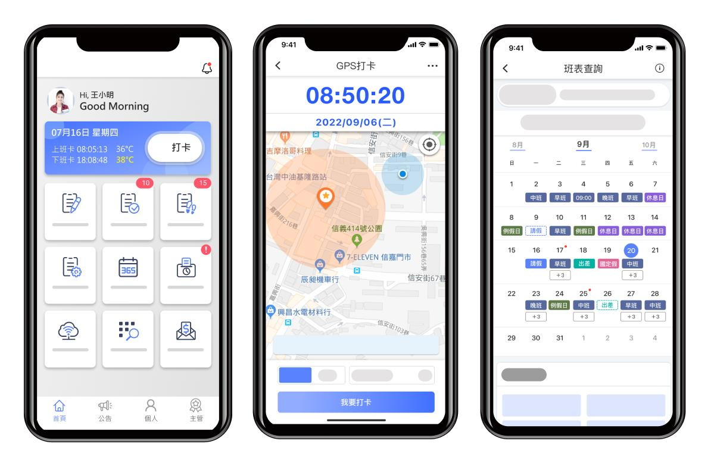
ehr.104.com.tw
Employees should be able to check in and out through the web application or a mobile-responsive interface.
Attendance functionality
- Assign employees to shifts and rotating rosters.
- Configure working days, grace periods, breaks, overtime rules and public holidays.
- Record check-in, check-out, late arrival, early departure and missed punches.
- Capture device location coordinates and reported accuracy at check-in/out.
- Optionally validate attendance against approved worksite geofences.
- Allow managers to review location exceptions and manual corrections.
- Calculate worked hours and approved overtime.
- Flag duplicate punches, missing check-outs and suspicious patterns.
- Provide employee attendance history and manager team views.
- Support offline submissions only if explicitly designed, with delayed-sync indicators and server-side validation.
Location privacy and integrity: Browser-based location is permission-dependent and can be spoofed. Use server timestamps, accuracy thresholds, reasonable geofence validation and exception review rather than treating GPS as conclusive proof. Explain the location collection policy to employees and restrict access to location data.
C. Overtime and additional-duty payment
I'll interpret your term overpayment as overtime or additional-duty pay calculated as N times the base pay rate. If you mean a different type of payment, the same configurable rules engine can support it.
Example:
Calculation | Example
Base hourly rate | £20
Approved overtime hours | 5
Overtime multiplier | 1.5×
Additional payment | £150
Formula:
\[ \text{Additional Pay}=\text{Hours}\times\text{Base Hourly Rate}\times N \]
The system should support:
- Configurable multipliers such as 1.0×, 1.5×, 2.0× or custom values.
- Rules by employee grade, shift, holiday, department and overtime category.
- Fixed allowances or additional-duty rates where required.
- Minimum eligible duration, rounding rules and maximum-hour limits.
- Supervisor submission and manager/HR/Accounts approval.
- Effective-dated rules and a record of the rule used for each calculation.
- Separation of claimed, approved, calculated and paid amounts.
- Prevention of duplicate overtime claims and payroll inclusion.
Use integer minor currency units for monetary calculations and decimal or integer-based rates rather than binary floating-point arithmetic. Payroll rules should be validated against the applicable employment and tax requirements.
D. Payroll, payslips and salary certificates
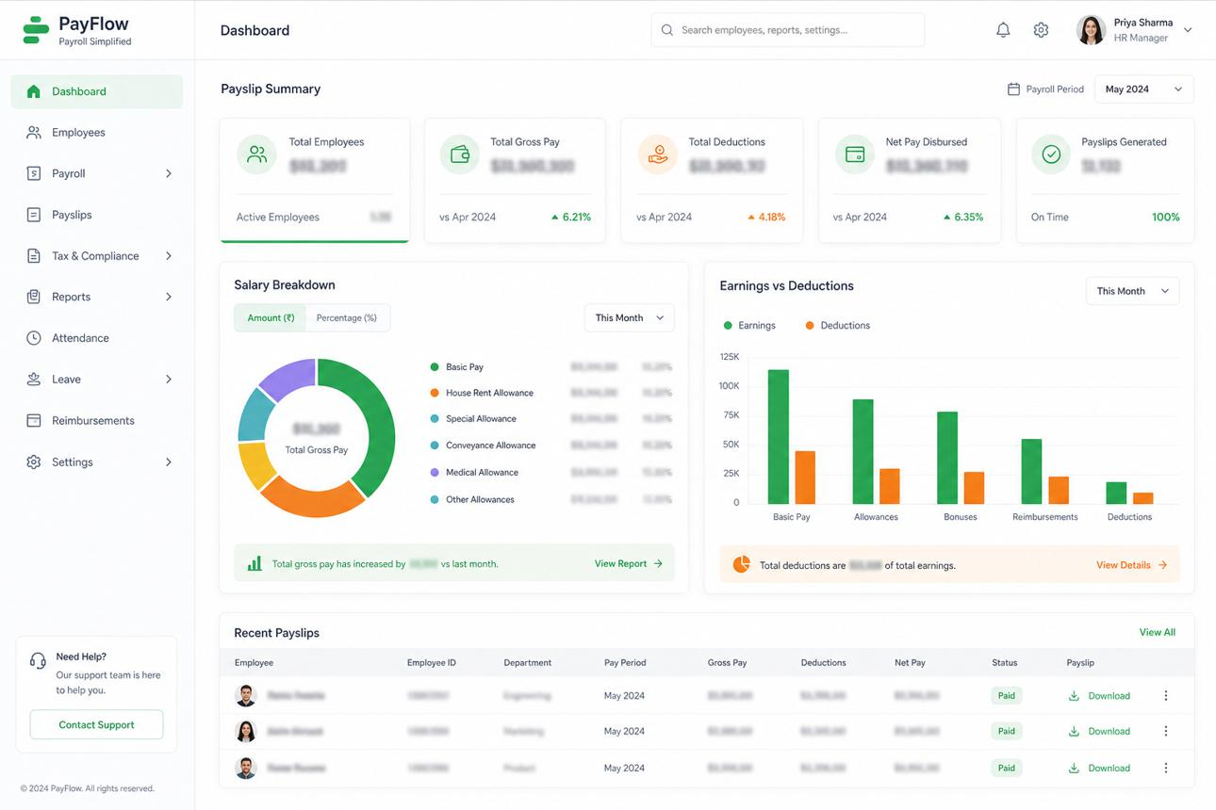
shivtatva.tech
Payroll processing
- Create a payroll period.
- Import approved attendance, overtime, allowances and deductions.
- Calculate gross pay, deductions and net pay.
- Flag anomalies and compare with previous periods.
- Submit the payroll for review and approval.
- Lock the approved payroll run.
- Record payment status, reference and payment date.
- Generate payslips and notify employees.
A basic salary model is:
\[ \text{Gross Pay}=\text{Base Pay}+\text{Allowances}+\text{Approved Overtime} \]
\[ \text{Net Pay}=\text{Gross Pay}-\text{Deductions} \]
Tax, pension, social contributions and other statutory calculations must be implemented through jurisdiction-specific, versioned rules or an appropriate payroll integration. Do not assume these are identical in every country.
Payslips should contain:
- Employer and employee details.
- Payroll period and payment date.
- Basic salary, allowances and overtime.
- Deductions and applicable tax information.
- Gross pay, net pay and currency.
- Payment status and payroll reference.
Salary certificate workflow
An employee submits a request specifying the certificate type and intended use. HR verifies employment information; Accounts validates salary details where required. The authorized approver issues a PDF containing only the information appropriate for that certificate.
Support certificate templates, expiry or validity periods where relevant, digital verification codes, revocation and a complete issuance history. Employees should only be able to access their own payslips and certificates.
E. Document management and expiry alerts
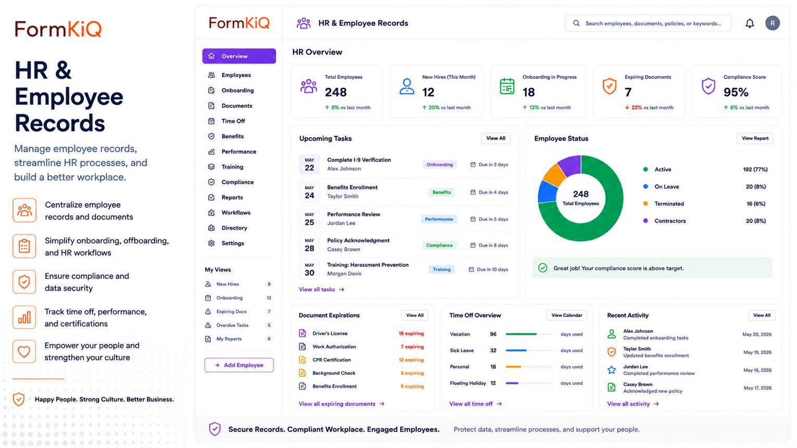
formkiq.com
Each document record should include:
- Document type and employee.
- File reference, version and upload timestamp.
- Issue date, expiry date and verification status.
- Issuing authority and optional reference number.
- Visibility classification and access policy.
- Reviewer, review date and notes.
- Retention policy and archive status.
Configure document categories and required-document rules by employee type, location and job role.
Automated alerts should be configurable, for example, 90, 30, 7 and 1 day before expiry, plus an overdue alert. Notifications should go to the employee, HR and the relevant manager according to policy.
Store files securely outside publicly served directories, use authenticated downloads, validate file type and size, scan uploads for malware when supported, and encrypt sensitive storage where appropriate.
F. Email notifications and scheduled automation
Provide a configurable notification center and email templates for:
- Employee creation, updates and approval decisions.
- Check-in/check-out events and attendance exceptions.
- Shift assignment and roster changes.
- Overtime submissions and approvals.
- Payroll approval, payment completion and payslip availability.
- Salary certificate requests and issuance.
- Upcoming document expiry.
- Probation, contract and employment anniversaries.
- Leave and other employee requests.
- Failed integrations, scheduled jobs and security alerts.
Do not send sensitive salary information or identity documents as ordinary email attachments by default. Prefer authenticated links to the application.
Use a durable notification queue, retry policy, deduplication, delivery status, configurable quiet hours and an outbox pattern so a committed business transaction does not lose its notification.
G. AppDynamics integration and AI help assistant
AppDynamics integration
Build an integration layer that can make authenticated API calls to the AppDynamics APIs needed by your deployment. Depending on your AppDynamics setup, this may include application health, metrics, events, incidents or business transaction information.
Provide:
- Configurable endpoint, authentication method, timeouts and polling interval.
- Secure secret storage.
- Retry with exponential backoff and rate-limit handling.
- Request correlation IDs, logs and error tracking.
- A configuration and test-connection screen.
- A health dashboard showing last successful synchronization.
- Mock integration mode for local development and testing.
AppDynamics should be an integration, not a dependency for ordinary HR operations. A monitoring API failure must not prevent employees from checking in or HR from processing requests.
AI help assistant
The AI assistant should answer questions such as:
- "How do I request a salary certificate?"
- "Why was my attendance marked late?"
- "When does my contract expire?"
- "How do I submit an overtime request?"
- "How many documents are awaiting my review?"
It should use approved HR policies, application help documentation and permission-filtered business data. It should explain how to complete an action, and only perform actions when an authenticated, authorized workflow supports them.
Never let the AI independently approve payroll, alter salaries, expose another employee's records or bypass workflow approvals. Record AI-assisted actions and require confirmation for sensitive operations.
4. Additional features expected of a robust HRMS
Leave and absence management
Configurable leave types, balances, accruals, holidays, requests and approval chains.
Onboarding and offboarding
Checklists, equipment handover, account access tasks, exit dates and clearance workflows.
Organization and workflow builder
Departments, reporting relationships, conditional approvals, delegation and escalation.
Reports and analytics
Headcount, attendance, overtime costs, payroll summaries, expiring documents and exports.
Security and audit
MFA support, least-privilege access, immutable-style audit history, session management and access reviews.
Configuration center
Company settings, currencies, time zones, shifts, pay rules, email templates, custom fields and feature flags.
Localization
Localized dates, currencies, time zones, configurable workweeks and translation support.
Reliability and recovery
Database backups, restore testing, health checks, migration tooling, monitoring and incident diagnostics.
5. Technical architecture: Go + SQLite
Frontend
Responsive web application · Employee and Admin portals
Go REST API
Authentication · Authorization · Validation · OpenAPI
Domain services
HR · Payroll · Attendance · Documents
Workflow services
Approvals · Notifications · Scheduler
SQLite
Transactions · Migrations · Audit
External services
SMTP · AppDynamics · AI provider
Recommended technology stack
Component | Recommendation
Backend | Go with a maintained Go release
API | REST/JSON with versioned /api/v1 endpoints and OpenAPI
Database | SQLite using a maintained Go SQLite driver
Data access | database/sql with explicit repository and transaction boundaries
Migrations | Versioned SQL migrations
Frontend | React + TypeScript with a reusable component system
UI styling | Tailwind CSS or an equivalent consistent design system
Authentication | Secure server sessions or OIDC; MFA support for privileged users
Authorization | RBAC plus organizational and record-level policy checks
PDF generation | Server-side PDF templates for payslips and certificates
Email | SMTP or a transactional email provider
Background jobs | Persistent job/notification queue backed by the database
API documentation | OpenAPI/Swagger
Testing | Go unit, integration and API tests; frontend component and end-to-end tests
Deployment | Docker, environment-based configuration, health checks and structured logs
Important SQLite production consideration: SQLite is a reasonable starting point for a single-instance application with moderate write concurrency. Enable foreign keys, use WAL mode where appropriate, configure busy timeouts, keep write transactions short and test concurrency under expected load. Avoid putting a live SQLite database on an arbitrary network filesystem.
Keep the data-access layer portable so that you can move to PostgreSQL when multiple application instances, higher write throughput or more complex concurrent workloads become necessary.
6. Master AI prompt — build the complete HRMS
Copy the prompt below into your preferred AI coding agent. It is designed to direct the agent to build a working application rather than just generate attractive mockups.
PeopleOps HRMS — Master Build Prompt
Full-stack application · Go · SQLite · React
Role and objective
You are a senior software architect, Go backend engineer, frontend engineer, database designer, security engineer and product designer. Design and implement a production-oriented Human Resources Management System (HRMS) named PeopleOps.
Build a complete, usable application with a responsive frontend, a Go REST API, SQLite persistence, approval workflows, configurable business rules, secure employee document management, payroll calculations, attendance tracking, email automation and external API integrations.
Do not stop at a design mockup, static dashboard, demonstration-only frontend or a collection of unimplemented API stubs. Implement end-to-end business workflows with persistent data, validation, error handling, authorization and automated tests.
A. Technology requirements
- Backend: Go, using a maintained stable release.
- Database: SQLite with foreign keys, versioned migrations and appropriate transaction management.
- Data access: database/sql with a maintained SQLite driver and a repository layer.
- Frontend: React, TypeScript, a modern build system and a consistent component library.
- API: REST/JSON under /api/v1, documented using OpenAPI.
- Authentication: secure sessions or OIDC, password hashing when local authentication is enabled, MFA support for privileged users, session revocation and secure logout.
- Authorization: RBAC combined with organizational scope and record-level access control.
- Documents and generated PDFs: private storage with authenticated access.
- Email: provider-independent email service with configurable SMTP or transactional provider settings.
- Background tasks: persistent notification and scheduled-job processing.
- Deployment: Docker support, environment-based configuration, health endpoints, structured logs and backup/restore instructions.
Keep modules separated, interfaces testable and configuration external to business logic. Pin dependencies appropriately and document the supported runtime environment.
B. Organization, users and permissions
Implement configurable organizations, departments, teams, work locations, designations, grades, cost centers and reporting relationships.
Provide these default roles:
- Super Admin
- HR Admin
- HR Approver
- Accounts / Payroll
- Accounts Approver
- Department Manager
- Shift Supervisor
- Employee
- Auditor / Read-only
Allow administrators to create roles, permissions and organizational scopes. Support users with multiple roles, configurable approval delegation, separation of duties, reporting-line checks and restrictions on self-approval.
Enforce authorization on the server for every protected endpoint. Hiding a button in the frontend is not authorization.
C. Employee lifecycle management
Implement:
- Employee creation, viewing, editing, search, filters, pagination and controlled export.
- Unique employee IDs and configurable custom fields.
- Employment status, contracts, joining dates, probation and termination.
- Departments, positions, managers and organization hierarchy.
- Salary structure and effective-dated compensation history.
- Emergency contacts and configurable employee information fields.
- Onboarding, offboarding, archive and employee reactivation workflows.
- Duplicate detection and field-level validation.
- Import templates with preview, validation and error reporting.
Model proposed employee changes separately from approved employee records. Support draft, submitted, pending HR, pending Accounts, approved, rejected and cancelled states where applicable.
Apply changes atomically after all required approvals. Preserve before-and-after values in the audit history.
D. Configurable approval workflow engine
Build a reusable approval engine instead of implementing unrelated hardcoded approval logic for every module.
It must support:
- Configurable workflow definitions and versions.
- Sequential approval steps, conditional routing and optional parallel approval.
- Approval by role, named user, manager or department.
- Threshold-based routing for financial changes.
- Approve, reject, return for correction, resubmit and cancel.
- Mandatory comments for configured decision types.
- Delegation, escalation, due dates and reminders.
- Separation of duties and prevention of self-approval.
- Immutable decision history and timestamps.
- Workflow notifications and configurable SLA reporting.
Store the workflow definition version with each submitted request so configuration changes do not silently alter workflows already in progress.
Use the same engine for employee changes, compensation changes, overtime, payroll, salary certificates, attendance corrections, leave and document verification.
E. Shift planning and attendance
Implement shift templates, employee rosters, rotating schedules, breaks, grace periods, work calendars, holidays and configurable overtime eligibility.
Employees must be able to check in and check out through a responsive interface. Record server timestamps, reported coordinates, location accuracy, attendance source and relevant device/request metadata.
Support configurable geofences and worksite restrictions. Reject or flag invalid coordinates, excessive location uncertainty, duplicate events, missing punches and implausible event sequences. Treat browser location as untrusted input and support a documented exception-review process.
Implement:
- Attendance calendar and daily/monthly summaries.
- Late arrival, early departure, absence and missing-punch detection.
- Timesheet review and attendance correction requests.
- Manager and supervisor review.
- Offline-submission policy, if enabled, with delayed-sync disclosure.
- Location data access restrictions and configurable retention.
- Attendance reports and export permissions.
Prevent unauthorized modification of historical attendance. Approved corrections must retain the original event and the reason for correction.
F. Overtime and additional-duty compensation
Implement a configurable compensation rules engine for additional-duty payments.
Support multiplier-based calculations:
additional_pay = eligible_hours × base_hourly_rate × configured_multiplier
Example: 5 hours × £20 × 1.5 = £150.
Make the multiplier, eligible hours, rounding, thresholds, maximums and effective dates configurable by shift type, employee grade, holiday, department and compensation category.
Also support fixed allowances and other explicitly configured compensation components.
Define how monthly salary is converted into an hourly base rate through a configurable policy. Do not silently assume a divisor.
Store claimed hours, approved hours, applied rate, multiplier, calculated amount, approver decisions and payroll inclusion status. Prevent duplicate claims and changes to approved calculations without a controlled adjustment workflow.
Use precise decimal or integer-minor-unit monetary arithmetic. Never use binary floating-point for money.
G. Payroll and payslips
Build a payroll workflow with:
- Payroll period setup and employee eligibility.
- Approved compensation and attendance inputs.
- Earnings, allowances, deductions and approved overtime.
- Configurable, versioned payroll calculation rules.
- Anomaly checks and comparisons with previous periods.
- Draft calculations, validation reports and approval.
- Payroll locking, payment references and payment status.
- PDF payslip generation and employee self-service access.
- Payroll audit history and authorized exports.
- Controlled adjustments and reversal records.
Calculate gross pay from configured earnings and net pay from gross pay minus applicable deductions.
Implement jurisdiction-specific statutory payroll rules only when properly specified and validated. Otherwise provide a clearly documented rules interface and integration point. Never represent a generic tax calculation as legally compliant payroll.
Use deterministic calculation inputs, a calculation version and reproducible payroll snapshots. Prevent duplicate payroll runs for the same scope and period unless an authorized correction or rerun is recorded.
H. Salary certificate requests
Allow employees to request a salary certificate and select an approved certificate template and purpose.
Implement configurable HR and Accounts validation, approval, generation, issue date, verification code, document version, download history and revocation where supported.
Populate certificates from approved employment and compensation data only. Require authorization before issuing a certificate and do not permit the AI assistant to bypass approval.
I. Employee document vault
Implement document upload, private storage, versioning, metadata, expiry dates, verification, access permissions, retention and controlled download.
Support configurable document categories, required-document rules and review workflows.
Provide expiry alerts at configurable intervals, for example 90, 30, 7 and 1 day before expiry, and an overdue notification.
Validate file size and file type, generate safe storage keys, prevent path traversal, protect against unauthorized direct access and provide an optional malware-scanning integration.
Do not expose uploaded documents through public static URLs. Store only file references and metadata in SQLite when files are stored in a private filesystem or object store.
J. Email and in-app notifications
Implement reusable, configurable email templates and in-app notifications for employee changes, approvals, attendance, shift changes, overtime, payroll, payslips, salary certificates, document expiry, contract deadlines and system incidents.
Use a transactional outbox or equivalent reliable design, persistent job records, retries with backoff, deduplication, delivery tracking, failed-job handling and administrator visibility.
Email should contain only the minimum necessary sensitive information. Prefer authenticated links for payroll and document access.
Support template preview, test delivery, notification preferences and configurable recipients. Scheduled tasks must be idempotent so restarts do not generate duplicate alerts.
K. AppDynamics integration
Create a dedicated integration module for the required AppDynamics API endpoints.
Support configurable base URL, authentication, secrets, timeouts, polling intervals, pagination, retries, rate limits, correlation IDs and integration-health reporting.
Implement only API operations supported by the configured AppDynamics environment. Keep the integration isolated from core HR workflows.
Provide a mock provider for local development, automated tests and environments without external credentials. Store secrets outside source control and redact them from logs.
L. AI help assistant
Create a contextual AI help assistant accessible from the application.
It should answer questions using approved HR policies, help articles and authorized employee-specific data. Examples include attendance guidance, certificate requests, document requirements and workflow status.
Use a provider abstraction, configurable model and endpoint, request timeouts, token limits, error handling and cost controls.
Apply authorization before retrieving information for the AI. Treat employee data and uploaded document content as untrusted input. Protect against prompt injection, cross-employee data leakage and unauthorized tool execution.
The assistant may explain or prepare an action, but must not independently approve payroll, alter compensation, issue certificates or bypass existing permissions. Require user confirmation for sensitive supported actions and audit those actions.
If no AI provider is configured, show a clear unavailable state and retain access to ordinary help documentation.
M. Administration and configuration center
Build a configuration UI for:
- Organization details and legal entities.
- Roles, permissions and approval workflows.
- Employee fields, statuses and employee ID formats.
- Departments, grades, job titles and cost centers.
- Shifts, calendars, geofences and attendance rules.
- Overtime multipliers and compensation policies.
- Payroll components, deductions and certificate templates.
- Document categories, expiry schedules and retention.
- Email providers, templates and notification schedules.
- AppDynamics and AI provider configuration.
- Feature flags, locale, time zone and currency.
- Data export, audit retention and operational settings.
Validate configuration changes, record who changed them, version important business rules and preview the impact where practical. Do not require code changes for ordinary business configuration.
N. Reporting and dashboards
Build role-specific dashboards for employees, managers, HR, Accounts and administrators.
Include authorized views for headcount, employee status, attendance, late arrivals, overtime hours and costs, payroll totals, pending approvals, document expiry, contracts, notification failures and integration health.
Support date filters, department filters, search, pagination, CSV export and print-friendly reports where appropriate.
Never expose salary, bank details, location history or personal documents in a dashboard to users lacking permission.
O. Data model and database design
Design normalized, migrated SQLite tables for at least:
- organizations, users, roles, permissions and role assignments;
- departments, locations, designations, reporting relationships;
- employees, employee change proposals and compensation history;
- shifts, rosters, attendance events, timesheets and corrections;
- overtime claims, compensation rules and allowances;
- payroll periods, payroll runs, earnings, deductions and payslips;
- employee requests, certificates and generated document references;
- document metadata, document versions and verification history;
- workflow definitions, versions, instances, approval tasks and decisions;
- notification templates, outbox, jobs and delivery attempts;
- integration configuration references and integration execution logs;
- AI interaction audit metadata where appropriate;
- audit events, application settings and idempotency records.
Use primary keys, foreign keys, appropriate unique constraints, indexes and explicit deletion policies. Use UTC timestamps internally and store the relevant business time zone for date and attendance interpretation.
Use transactions for multi-record business operations. Enable foreign keys on every SQLite connection. Choose WAL and connection-pool settings deliberately, and document SQLite's concurrency limits.
Design repositories and migrations so a future PostgreSQL migration is feasible without making SQLite-specific assumptions throughout the business layer.
P. Security, privacy and audit requirements
Implement:
- Secure authentication, session expiry and revocation.
- MFA support for privileged accounts.
- CSRF protection when cookie-based authentication is used.
- Strict input validation and output encoding.
- Rate limiting and login abuse protection.
- Secure cookie and transport settings.
- Secret management and password hashing.
- Record-level authorization and separation of duties.
- Sensitive-field masking and restricted document access.
- Append-only audit events with actor, action, timestamp, target and change summary.
- Audit access to sensitive records and downloads where appropriate.
- Configurable retention and data export/deletion workflows.
- Automated backup, recovery procedures and restore tests.
- Dependency scanning and security-focused automated tests.
Do not log passwords, authentication tokens, full bank details, document contents or unnecessary location data. Never use real employee data or credentials in seeded development fixtures.
Q. API design
Create documented, versioned REST endpoints grouped by domain, including:
/api/v1/auth
/api/v1/employees
/api/v1/organization
/api/v1/attendance
/api/v1/shifts
/api/v1/overtime
/api/v1/leave
/api/v1/payroll
/api/v1/payslips
/api/v1/salary-certificates
/api/v1/documents
/api/v1/workflows
/api/v1/approvals
/api/v1/notifications
/api/v1/reports
/api/v1/admin/config
/api/v1/integrations/appdynamics
/api/v1/assistant
Use consistent status codes, validation errors, pagination, filtering, request IDs and API error structures. Add idempotency protection for operations where repeated requests could create duplicate financial or workflow effects.
R. User interface requirements
Build a polished, responsive enterprise interface with a collapsible sidebar, searchable tables, filters, pagination, profile pages, forms, approval inboxes, status indicators, confirmation dialogs and useful empty/loading/error states.
Provide role-specific navigation, accessible form labels, keyboard navigation, consistent spacing, responsive layouts and clear visual hierarchy.
Use reusable components and design tokens. Support light and dark themes if practical. Make complex forms understandable through sections and validation messages.
Build working screens, not placeholders. Every primary button must perform its intended action or clearly indicate that the required configuration is missing.
S. Testing and acceptance criteria
Provide unit tests, integration tests, authorization tests, migration tests and frontend end-to-end tests.
Verify at least these scenarios:
- An employee cannot view another employee's private information.
- An employee update requiring HR and Accounts approval does not become effective prematurely.
- An approver cannot approve their own restricted transaction.
- A configured overtime multiplier produces the expected amount.
- Duplicate attendance events and duplicate payroll submissions are handled safely.
- An employee can access only their own payslips and authorized certificates.
- Expiring documents generate the correct notifications without duplicate sends.
- Email and AppDynamics failures do not corrupt core HR transactions.
- A database backup can be restored and verified.
- Important business actions create audit events.
- Invalid or unauthorized API requests fail safely.
- The application remains usable at the supported viewport sizes.
T. Required deliverables and implementation process
Deliver:
- A documented architecture and module breakdown.
- An entity-relationship diagram and database migrations.
- A working Go backend and React frontend.
- OpenAPI documentation.
- Seeded demo organization, fictional employees and sample workflows.
- Configurable sample shifts, overtime multipliers, document categories and notification templates.
- Automated tests and instructions to run them.
- Docker configuration and a production deployment example.
- .env.example with placeholder values only.
- Backup/restore documentation, operational runbooks and security notes.
- An implementation checklist distinguishing completed features from limitations and future integrations.
Start by producing the architecture, database model, key workflow diagrams and implementation plan. Then implement a vertical slice from database to API to frontend, beginning with authentication, roles, employee management and approval workflows. Continue through attendance, overtime, payroll, documents, notifications and integrations.
After each module, run the relevant tests, resolve failures and update the checklist. Do not mark an integration as complete until it has been implemented and tested against either a real supported API or a documented mock.
Prioritize correctness, security, maintainability and operational reliability over adding superficial features. Do not claim production readiness merely because the application builds or starts successfully.
Copy short build instruction
7. Recommended project structure
Keep the code organized by business domain instead of creating one large handler file.
peopleops/
├── cmd/
│ └── server/
│ └── main.go
├── internal/
│ ├── auth/
│ ├── authorization/
│ ├── employees/
│ ├── organization/
│ ├── workflows/
│ ├── attendance/
│ ├── shifts/
│ ├── overtime/
│ ├── payroll/
│ ├── certificates/
│ ├── documents/
│ ├── leave/
│ ├── notifications/
│ ├── integrations/
│ │ └── appdynamics/
│ ├── assistant/
│ ├── reports/
│ ├── audit/
│ └── platform/
├── migrations/
├── web/
│ ├── src/
│ │ ├── components/
│ │ ├── pages/
│ │ ├── features/
│ │ ├── hooks/
│ │ └── api/
│ └── package.json
├── deployments/
├── scripts/
├── docs/
├── tests/
├── Dockerfile
├── docker-compose.yml
├── .env.example
├── go.mod
└── README.md
8. Implementation roadmap
I recommend building the platform in stages so that the fundamental security and workflow architecture is proven before payroll and integrations are introduced.
Phase 1 — Foundation
Build first
Authentication, roles, organization hierarchy, employee records, database migrations, audit history and approval engine.
Phase 2 — Attendance and HR operations
Shifts, GPS attendance, overtime claims, leave requests, document uploads, expiry alerts and employee self-service.
Phase 3 — Payroll and certificates
Configurable compensation rules, payroll processing, payslip generation, salary certificates, approvals and payment notifications.
Phase 4 — Integrations and automation
AppDynamics integration, AI assistant, email automation, reporting and operational dashboards.
Phase 5 — Production hardening
Security reviews, concurrency tests, backup restoration, load testing, monitoring, deployment automation and recovery procedures.
9. Three important decisions before implementation
The master prompt establishes sensible defaults, but these details should be finalized before payroll and attendance rules are implemented.
Configure your initial build
Choose defaults below. You can leave them as shown or change them before generating a more specific implementation prompt.

1. Country and payroll jurisdiction
United Kingdom
United Arab Emirates
India
Multiple countries / configurable jurisdictions
Other / undecided
2. Deployment scale
Single server — SQLite, initial deployment
Multiple application instances — design migration path to PostgreSQL
3. Salary and payment model
Monthly salary + overtime
Hourly wages + overtime
Monthly salary + shift allowances + overtime
Multiple configurable pay models
4. Authentication
Email and password + MFA
Microsoft Entra ID / enterprise SSO
Local login and OIDC / SSO
5. Employee change approvals
HR → Accounts for relevant changes
Manager → HR → Accounts
Configurable by transaction type and amount
6. Location verification
GPS + configurable worksite geofence
GPS capture without geofence enforcement
GPS + geofence + supervisor exception review
Generate tailored implementation specification

My recommendation: begin with the employee directory, permission model, reusable approval engine and audit trail. These are the foundation for reliable HR changes, attendance corrections, salary approvals and certificates. Then introduce payroll once the jurisdiction-specific compensation rules have been confirmed. Keep SQLite for the initial deployment, but design the data-access layer so you can migrate cleanly as the organization grows.

